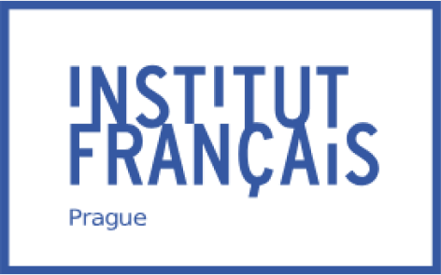

Štěpánská 35 | 111 21 Prague 1
Czech Republic
tel. : +420 221 401 022
ifp@ifp.cz

Operation of Café 35
at the Institut français de Prague _______________________________
Lease management

Management of Café 35 at the French Institute in Prague
The purpose of these specifications is to define all the terms and conditions for the occupation and use of Café 35, a convivial space at the Institut français de Prague, which must act in synergy with the activities offered throughout the cultural season and all other events organised on the IFP site.

1. Missions and activities at the Institut français de Prague (IFP)

Inaugurated in 1920, the Institut français de Prague promotes French language and culture in the Czech Republic. It is part of a network of 150 institutes throughout the world, and is one of the oldest.

As well as promoting French language and organising cultural activities, it encourages intercultural exchanges. Its programming, which includes a wide range of courses, exhibitions, lectures and film screenings on its premises, reflects its objectives by inviting speakers of many nationalities and programming films from a variety of backgrounds.

The Institut français de Prague is visited by a large number of people every day.

French courses
In 2023, more than 2,000 students, children, teenagers and adults took classes at the Institut français. In addition to traditional teaching, the Institute offers specialised French modules (business French, legal French, basic "survival" French for tourists). These courses are open to everyone, depending on their availability and interests. Around thirty teachers teach at the institute.

Cultural activities
In addition to its 'off-site' activities, the Institut français has a cinema, Kino 35, a media library, an art gallery (Galerie 35), a French-language bookshop and a convivial café-restaurant: Café 35.

With a capacity of 203 seats, the EUROPA CINEMA-labelled Kino 35 offers a wide choice of films for Czech, English and French-speaking audiences. Its programme of heritage films and new releases alternates with festivals and distributor previews. In 2023, 613 screenings were attended by over 16,600 people from Monday to Saturday, in the afternoons and evenings. This space has just undergone a complete aesthetic refresh, underlining its link with French cinematographic creation.

An open window on contemporary France, the media library (mediathèque) offers a wide range of freely-accessible books, including DVDs, classic literature and the latest releases, comics, poetry and a vast selection of children's books.
There is also a video games area (Digital 35) and a programme of debates, literary evenings and writing workshops.
Nearly 4,000 people are registered with the media library. Open 35 hours a week from Tuesday to Saturday, it is frequented by up to 100 people a day. The lending/return service at the reception desk and the automatic lending machine will enable books to be borrowed and returned over a wide range of hours (possibly on Sundays too).

The various events on offer in these areas can be organised in conjunction with the Café 35, that would handle the catering service.

Space for hire
IFP is offering a large conference/meeting/seminar space for hire (80 persons), in addition to the offices already rented on the 4th floor. The manager of Café 35 will need to be able to carry orders for coffee breaks, refreshments and catering services. It will also be able to take advantage of these potential customers to offer a suitable range of meals for lunch during the week.
In addition, it will find in the many businesses located in the district another significant potential of growth.

2. General characteristics of Café 35

Café 35 will operate on the basis of the following activities:

1/ Bar activity

The expected characteristics of the venue are as follows:

- A space where people can meet and talk, with a "French-style" atmosphere
- A range of drinks and light snacks (cakes, sandwiches, croissants, croque-monsieur, etc.) covering breakfast, light lunch, aperitifs and after-work drinks (with the Happy Hour formula)
- A pricing policy allowing access to all, including students and IFP staff, with a loyalty or discount program for IFPass card holders and employees;
- Be a partner in IFP activities: catering and coffee-break provider.

2/ Bistro activity

The expected characteristics of the venue are as follows:

- A friendly, welcoming place, with a French atmosphere (decoration, background music....);
- Fast food, with a menu of the day, based on fresh, quality products, reminding the classics of the French culinary tradition;
- An attractive pricing policy allowing access to all (especially IFP students and staff, school groups);

3/ Tearoom activity

The expected characteristics of the premises are as follows:

- An offer of pastries and drinks in the afternoon
- A cosy atmosphere

4/ Events

The expected characteristics of the venue are as follows:

- To be a partner in the activities of IFP and its tenants: to provide cocktails, coffee breaks, working meals and other "catering" services on site, to take away or within the departments concerned.

5/ Delicatessen-grocery shop

The expected characteristics of the premises are as follows:

- Offer a range of French products: preserves, terrines, foie gras, fruit in syrup, biscuits, juices, wines, spirits, charcuterie, cheeses, etc.

Please note that a report has been produced by an auditor on this subject and is available in the appendix: Mood Board, trend book and inspiration for the new concept, Heuristic forecast with management recommendations.

3. Café 35 Management

3.1. Obligations of the occupier:

Café 35 is operated and managed by the operator.
In the premises made available and fitted out for this purpose, the operator offers food and drink to all IFP members of the public as well as to outside customers.

Events organised by IFP teams (conferences, temporary exhibitions, debates, concerts, etc.) may be offered to the operator.

Any action initiated by the operator must be approved by IFP management.

The operator must:

- Acquire additional equipment (cutlery/dishes, coffee machine/percolator, knives, pots and pans, etc.) specific to the catering trade. The operator will also be able to purchase additional decoration if he so wishes. These two points will be submitted to the Institute's management for approval;
- Manage the premises and equipment (bar, storage, storeroom, etc.);
- Ensuring the cleanliness and tidiness of the various premises provided, as well as waste disposal. The operator may, if he wishes, use the services of the IFP cleaning company at his own expense;
Make a request for outdoor furniture to be made available for the terrace during the summer period, making sure that access to the course building is not hindered, nor the running of the course, because of the noise. They may also offer their own furniture, subject to approval by the IFP management.
- Sell drinks and food during the Institute's opening hours;
- Respect and ensure respect of the laws and regulations relating both to the occupation of the premises and to the activity carried out. The operator is responsible for paying all taxes and fees relating to his professional activity.
- Promote its activity on the main social networks in conjunction with the IFP communications team. The operator must, however, ensure that all accounts linked to Café 35 are closed when the occupancy agreement ends. IFP's communications and marketing team will also be able to contribute (relaying the café's communications, providing resources, joint communications, etc.).

3.2. General operating conditions :

The IFP reserves the right, on an ad hoc basis, to privatise Café 35 (after consultation of the operator), to present, for example, collections from the media library or other events aimed at the public.
The operator will be able to use the media library's French-language record collection (3,500 CDs) to provide sound entertainment in the space.
The IFP may install a television set to broadcast French programmes (TV5 Monde, France 24....).
The media library team is available to advise the operator and guide him in his choices. The IFP also reserves the right to suggest titles or albums based on current French events. The operator must comply with the Czech law on the broadcasting of music in public places (OSA).

Annual closure dates at the initiative of the operator must be submitted to the IFP management for approval. During the year, the operator must ensure that Café 35 is open when the Institute's services are in operation.

A regular (weekly) meeting between IFP management and the operator will provide an opportunity to discuss and feed back any information required for the smooth running of Café 35.

3.2.1. Opening :

The proposed opening hours for Café 35 are: Monday to Friday from 8am to 9.30pm and Saturday from 9.30am to 6pm. Opening times are published on the Institute's website and social networks.

The IFP management and the operator reserve the right to jointly assess any changes to opening times.
A schedule of the Institute's recurring activities in the other IFP areas is sent to the operator every two months.
IFP is traditionally closed for one week during the Christmas and New Year period, which also means that Café 35 is closed during that period.

3.2.2. Exceptional opening :

As certain exceptional events take place at weekends, the Institute reserves the right to ask the operator to open Café 35 on an exceptional basis, for example during major festivals, sporting events or election nights...
In such cases, IFP undertakes to give the operator as much notice as possible approximately 15 days before the date of the event.

The operator may, if it so wishes, propose an exceptional opening for an activity of its own initiative, with the due approval of the Institute's management.

3.2.3. Menu and prices :

Menu
The operator will have to develop a menu adapted to the requirements of a café located within a French cultural space. The menu will be written in three languages: French, Czech and English.

With regard to the catering offer, in keeping with the French culinary tradition, the menu should be varied and original and should reflect the specific characteristics of the café (breakfast, salad, sandwiches, pastries, dish of the day and desserts, etc.). (See standard offer presented on the Mood Board)

Prices
Prices will have to be consistent with the proposed menu, including a price range wide enough to be accessible to all categories of the population and adapted to the public (students, employees, IFPass card members, etc.).
As Café 35 is also a venue for IFP students and staff, the operator is encouraged to offer attractive prices, particularly for coffee breaks and lunch.

3.2.4. Human ressources :

The operator must comply with the provisions of the Labour Code and the collective agreements applicable to its activity. The operator's staff should be able to speak French and/or English in addition to Czech. Their dress and behaviour must be compatible with their activity and with the image of the Institut français de Prague.

4. Assets made available

The property described below will be made available to the applicant who will be responsible for running Café 35.

The main 81.90 m2 space made available to the operator is located on the ground floor of the building and opens onto the inner courtyard (windows and door). Access to the premises is either via the terrace or from the building's entrance hall, via a corridor that includes access to two separate sanitary areas (male/female) with 2 washbasins and 2 toilets (including one accessible to the disabled in each of these areas). These washrooms are the only ones located on the ground floor of the building occupied by the Institut français de Prague and are used by both Café 35 customers and the Institut's public (exhibition gallery, media library, French classes, etc.).
The glass door opening onto the space adjoins the access to the staircase leading up to the IFP's media library.
The space also includes a 10.80 m2 fully-equipped kitchen (details of equipment in annex), a counter with cupboards and shelves, lights and a ceiling-mounted video projector with removable screen and a sound console.
Weather permitting, part of the terrace can be used to serve Café 35. The operator will ask IFP management to install and remove the furniture provided by IFP.

A 5 m2 storage area is available to the operator on the ground floor of the main building.

A telephone line is available to the operator in Café 35 with the national network. The operator will pay the cost of his calls to IFP on presentation of a quarterly invoice.

5. Maintenance and servicing obligations :

The operator will be responsible for the upkeep of all the real estate and personal property made available, with the exception of the heating and ventilation equipment in the premises made available. (The operator will be responsible for daily cleaning of the premises).

The operator will be required to maintain all the property and furnishings made available to it in a perfectly clean and hygienic condition (list attached), including air vents, kitchen hoods and glass surfaces.

In this respect, the operator will bear the cost of any repairs that may prove necessary as a result of damage caused by the operation of the premises, whether caused by the operator, its staff, its customers or its suppliers.

6. Insurance policy
The operator must take out an insurance policy covering all risks that may arise from the occupation, as well as recourse from neighbours.

7. Financial provisions, fees :

The operator will be submitted to a contribution, from the date of commencement of the delegation, in return for the goods made available, for the communication carried out internally and in IFP's external network, and for the services that the operator will be obliged to organise (business contributor) consisting of:

- A monthly occupancy fee of CZK 20,000, which may be updated and paid each month to the administrator of the French Embassy in the Czech Republic;
- A variable operating fee equal to 2% of pre-tax sales, payable in arrears. The operator undertakes to provide its operating accounts corresponding to its activity to the manager of the French Embassy in the Czech Republic;
- An advance on operating costs of CZK 12,000 paid each month to the IFP accounting officer. The actual costs will be adjusted twice a year on the basis of the meters (water and electricity) and in proportion to the surface area (contribution to gas heating costs).

8. Duration of the delegation :

The operator to whom the owner entrusts the occupation and use of Café 35 will hold the contract, except in the event of termination, for a period of 3 years from the date of signature of the contract, not tacitly renewable. It may, however, be expressly renewed in writing by IFP. IFP reserves the right to issue a call for tenders after the expiry of this period.

Annexes :

- Non-contractual plan of the ground floor of the Institute
- Inventory
- Mind map
- Moodboard

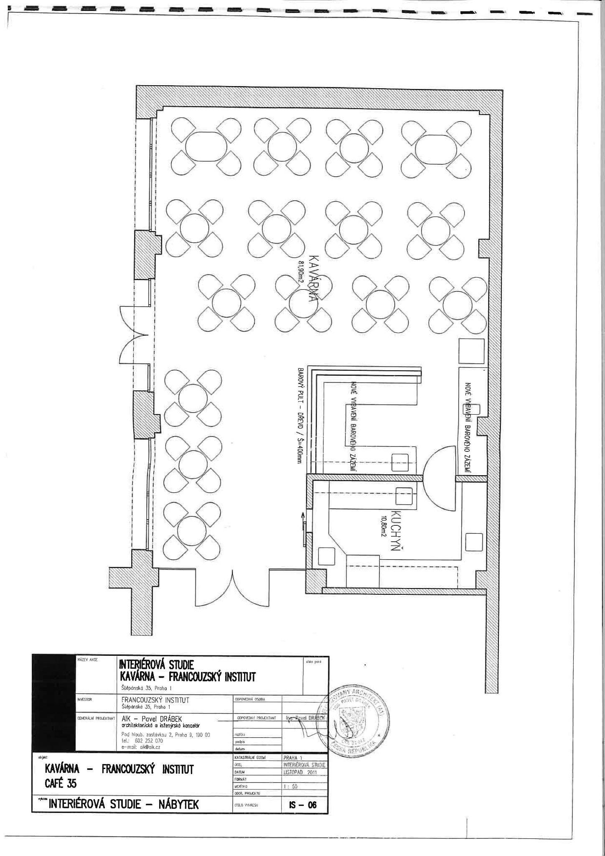
Annex: Map of facilities

Annex : Non-contractual inventory of Café 35 (subject to change)
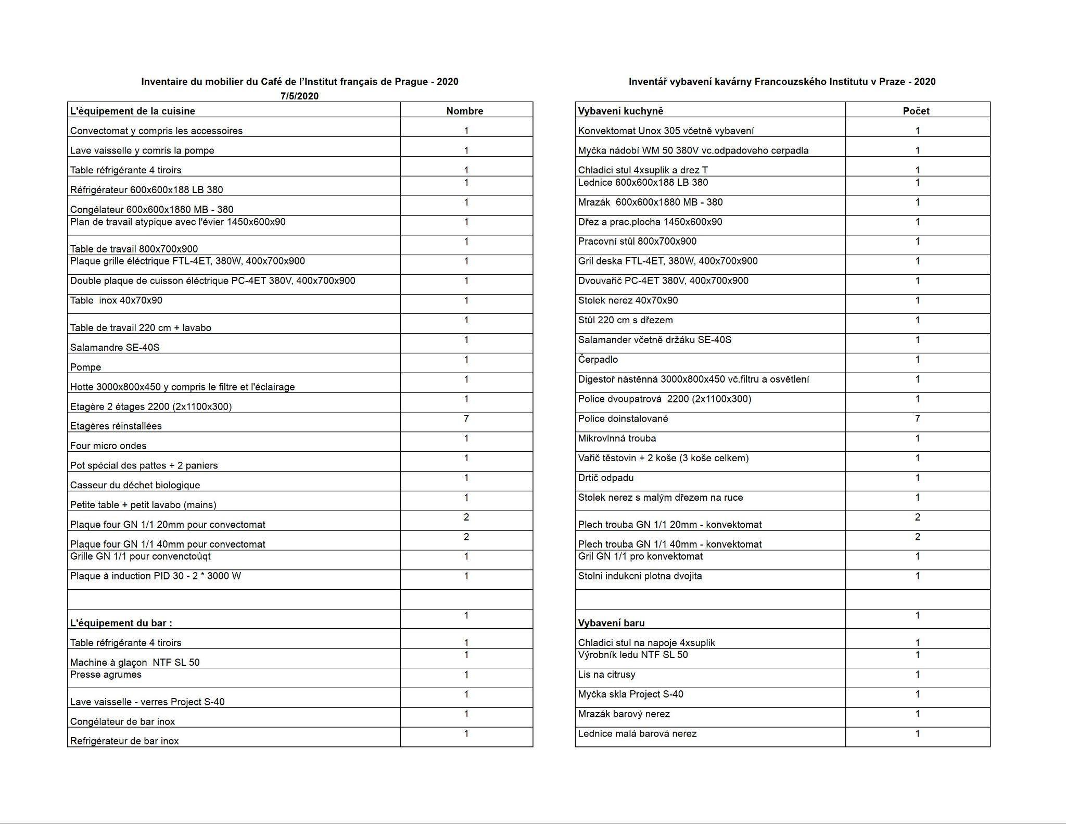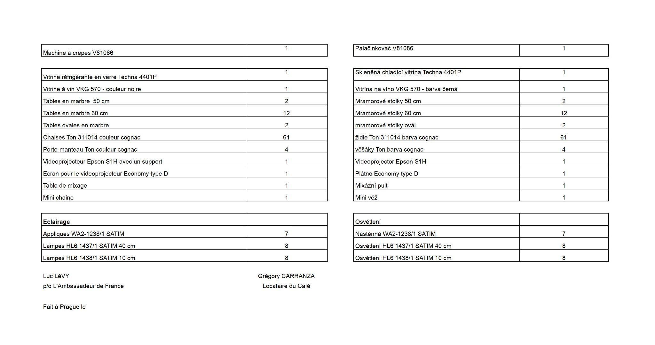

Annex : Heuristical mindmap of buisness Model

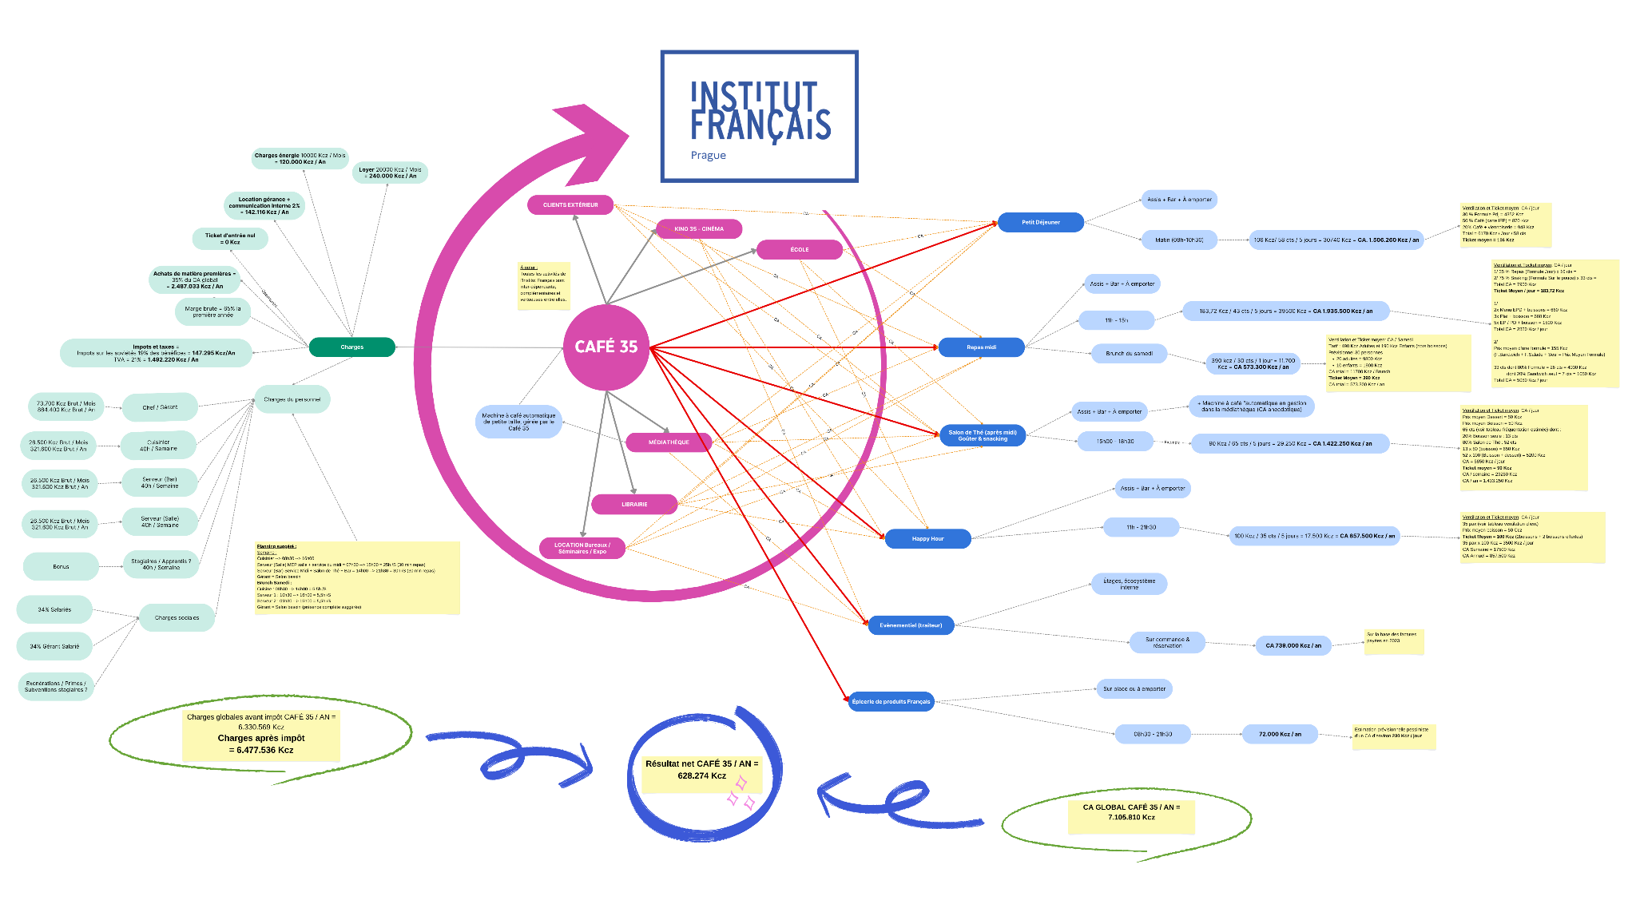

Annex : Mood Board (cahier de tendances concept Café 35)

